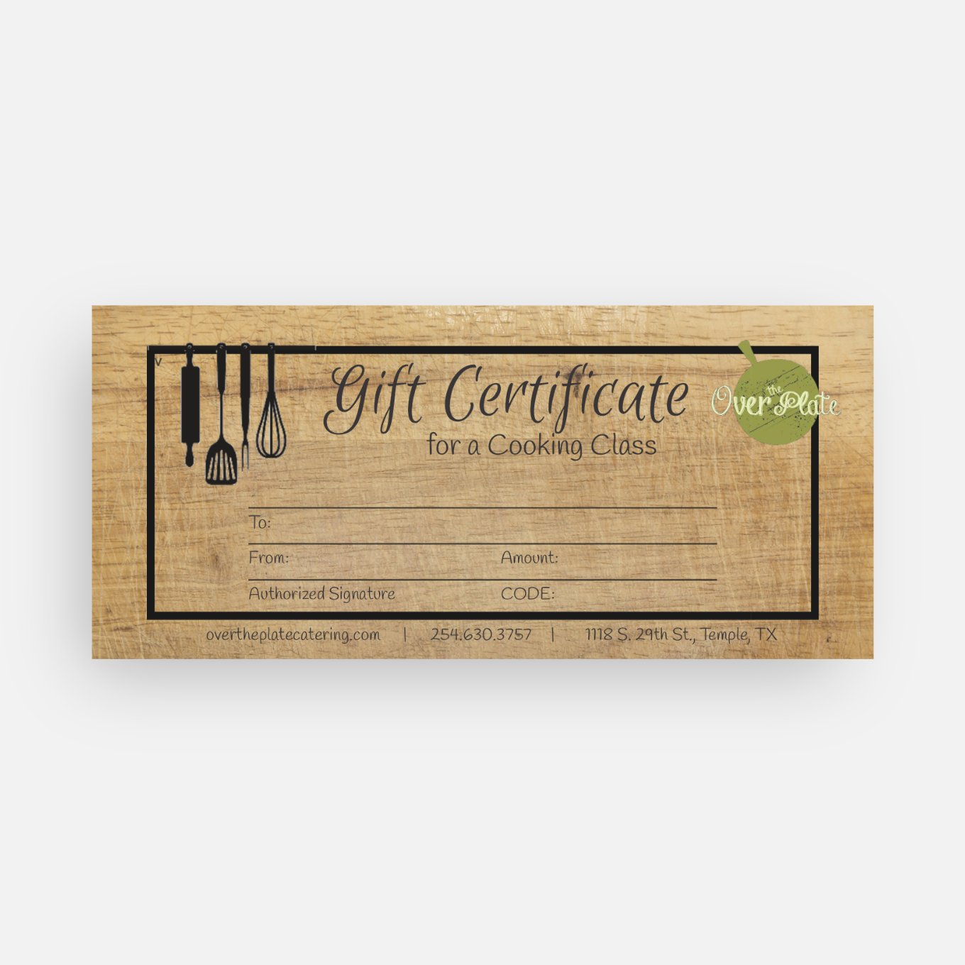

GIFT CERTIFICATE ORDER FORM

Please email the completed form to: [overtheplatecatering@gmail.com](mailto:overtheplatecatering@gmail.com)

Fill out the following information:

TO:

FROM:

AMOUNT:

METHOD OF PAYMENT:

Venmo: @kim-bates-wallace

Zelle: 254-630-3757

Check: Payable to Over the Plate (Mail to: 3901 Bella Vista Loop, HH, TX 76548

The name & address you would like the gift certificate to be mailed to: